Numerical Simulations of Heavy Rainfall Events in Malaysia in 2006/2007

Using the Cloud Resolving Model

Kazuhisa Tsuboki¹⁾, Taro Shinoda²⁾, Mitsuharu Nomura²⁾, and Masaya Kato²⁾
- Hydrospheric Atmospheric Research Center (HyARC), Nagoya University
/ Frontier Research Center for Global Change,
- Hydrospheric Atmospheric Research Center (HyARC), Nagoya University
Furo-cho, Chikusa-ku, Nagoya, 464-8601, JAPAN
e-mail: tsuboki@rain.hyarc.nagoya-u.ac.jp

ABSTRACT:
High-impact weather systems occasionally cause huge disasters to human society owing to heavy rainfall and/or violent wind. They consist of cumulonimbus clouds and usually have a multi-scale structure. High-resolution simulations within a large domain are necessary for quantitatively accurate prediction of the weather systems and prevention/ reduction of disasters. For the simulations, we have been developing a cloud-resolving model named the Cloud Resolving Storm Simulator (CReSS). The model is designed for parallel computers. In the present paper, we introduce the CReSS model and some results of high-resolution simulations of high-impact weather systems in a large calculation domain with resolving individual cumulonimbus clouds.
Characteristic high-impact weather systems in East Asia are the Baiu front, typhoons, and winter snowstorms. The present paper describes simulations of these significant weather systems. We have chosen for the case study of the Baiu front the Niigata-Fukushima heavy rainfall event on 13 July 2004. Typhoons for simulations are T0418 which caused a huge disaster due to strong wind, and T0423 which caused severe flood over the western Japan in 2004. These experiments clarified both the overall structures of weather systems and individual clouds. The high-resolution simulations resolving individual clouds permit a more quantitative prediction of precipitation. They contribute to accurate prediction of wind and precipitation and to reduction of disasters caused by high-impact weather systems.
In the present paper, we also show some preliminary results of simulation experiments of the Malaysia heavy rainfall event occurred in the winter of 2006/2007. During the period, there are some significant rainfalls. We chose the two intense rainfall events and performed simulations of rainfall; one is the heavy rainfall on 16-17 December 2006 and the other is on 12-13 January 2007. The computational domain is shown in the figure. The initial and boundary conditions are provided by the JRA-25 (the Japanese 25-year Reanalysis Project). For the most coarse grid domain, MM5 is used for computation. The CReSS model is used for high-resolution simulation nested in the MM5 output data. The simulated rainfall will be shown and compared with observed rainfall in the presentation.

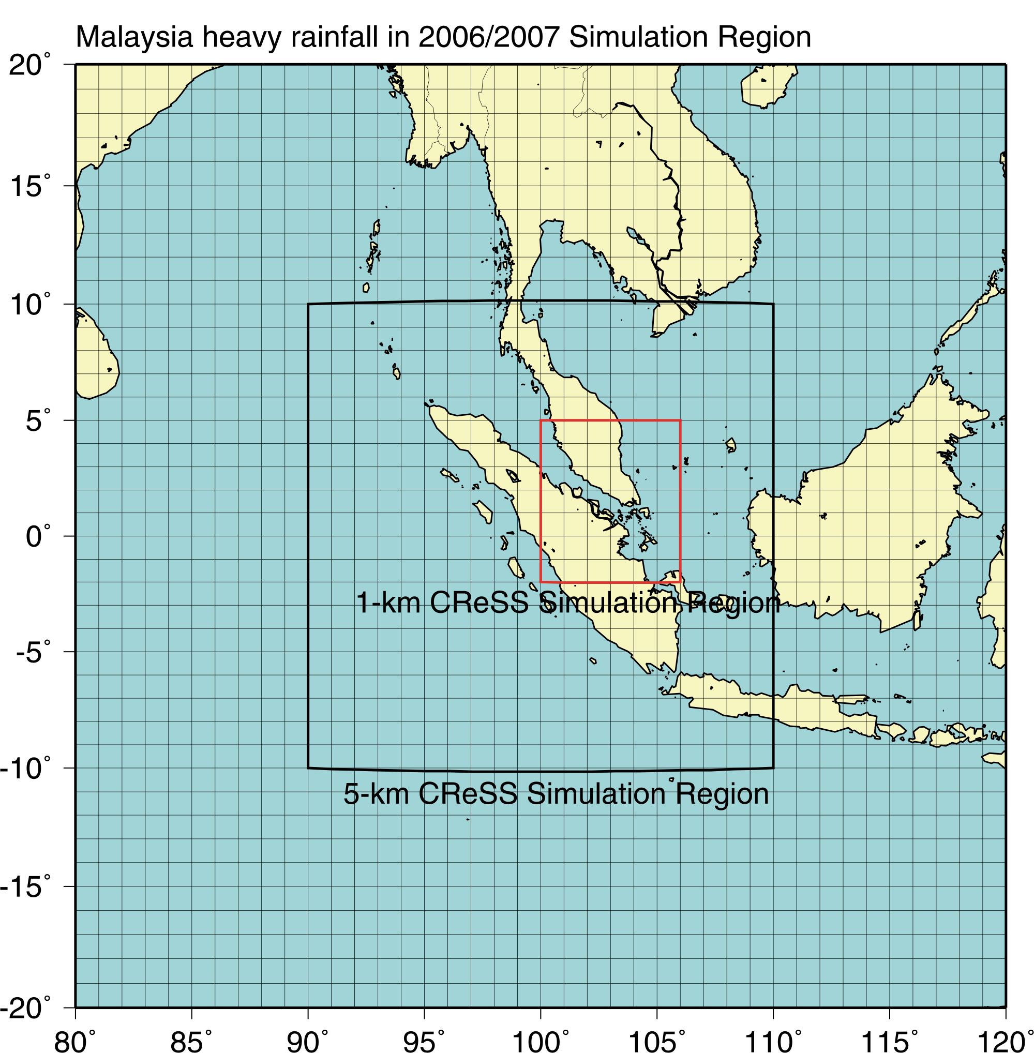
Figure: Domains of simulation of the Malaysia heavy rainfall events. The outermost domain is used for the MM5 experiment. It provides the boundary condition for high-resolution simulation using the CReSS model in the middle domain (5-km resolution). The red rectangular indicates the domain of 1-km resolution simulation.

